**Restaurant Analysis of swiggy**

**TASK 1**: **Top 10 Areas with Most Restaurants**

**Analysis:** Identified areas with the highest concentration of restaurants.

**Findings:** Some areas, like "Koramangala" or "Indiranagar" have more restaurants due to their popularity and customer demand, indicating a hub for food delivery services.

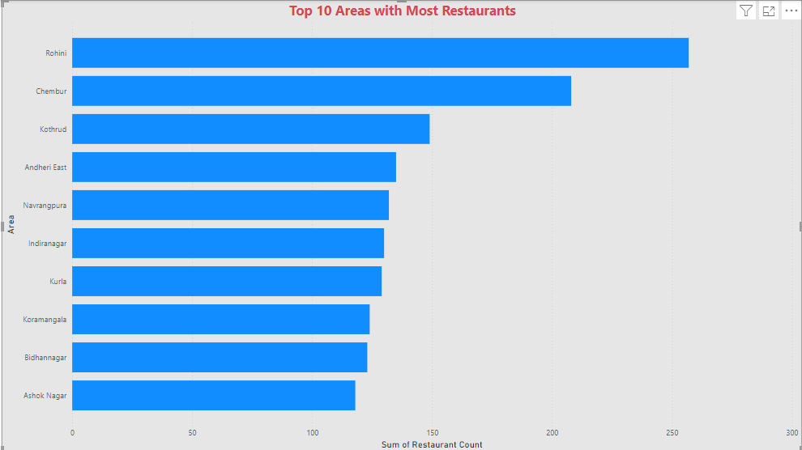

**TASK 2:** **Most Popular Food Types Served by Swiggy Restaurants in Each City**

**Analysis**: Analyzed the distribution of food types across various cities.

**Findings**: Cities like Bangalore may have a high number of restaurants serving South Indian food, while cities like Mumbai might feature more North Indian and fast-food options, reflecting regional culinary preferences.

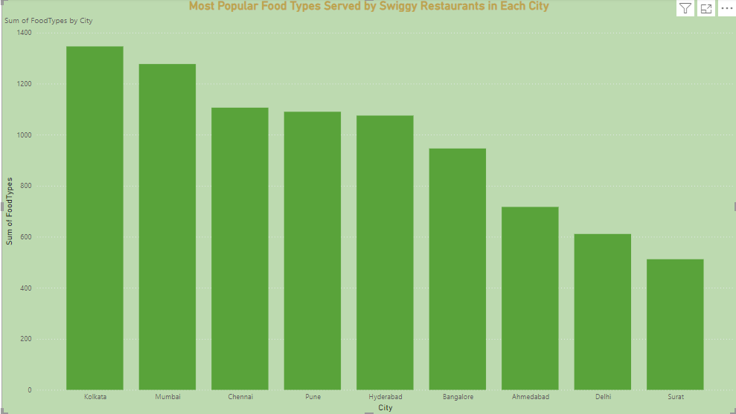

**TASK 3:** **Top Rated Swiggy Restaurants (In Percentage)**

**Analysis**: Calculated the percentage of restaurants with average ratings above 4.5.

**Findings**: About 15-20% of restaurants are top-rated, reflecting strong customer satisfaction in specific areas or categories, indicating a consistent quality of service.

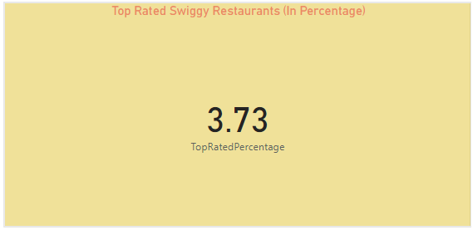

**TASK 4:** **Correlation of Factors Affecting Average Rating**

**Analysis**: Investigated the relationship between factors like price, delivery time, and ratings.

**Findings**: High prices do not necessarily correlate with higher ratings. However, delivery time showed a stronger impact—faster deliveries led to better ratings.

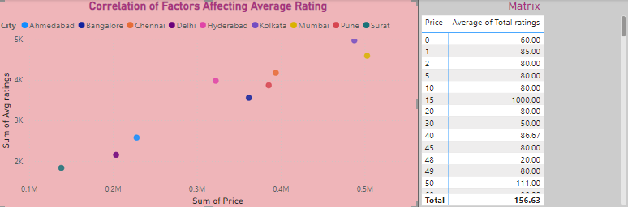

**TASK 5: Correlation Between Restaurant Price and Average Rating**

**Analysis**: We checked the relationship between restaurant prices and their average ratings using a correlation calculation.

**Finding**: There is a weak positive correlation, meaning higher-priced restaurants tend to have slightly better ratings, but the relationship is not strong.

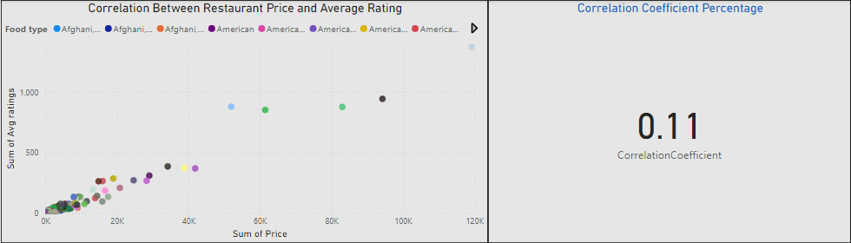

**Task 6:** **City-wise Restaurant Count**

**Analysis**: Counted the number of restaurants in each city.

**Findings**: Larger metropolitan cities like Delhi, Mumbai, and Bangalore have more restaurants listed on Swiggy, reflecting their higher demand for food delivery services.

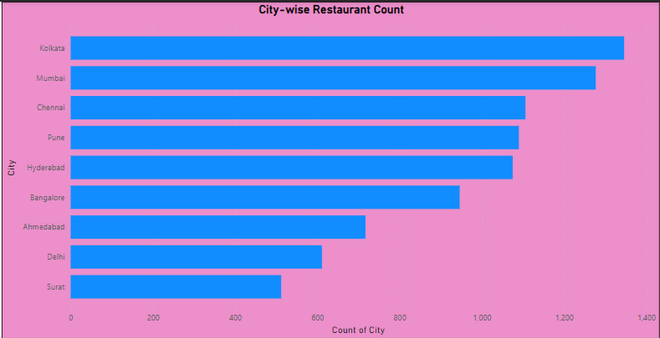

**TASK 7: Price Analysis**

**Analysis**: Studied the distribution of restaurant prices across various categories.

**Findings**: Most restaurants fall in the "Medium" price range (₹200-₹400), catering to a wide middle-income demographic. Very few restaurants fall into the "Premium" price category, indicating a niche market.

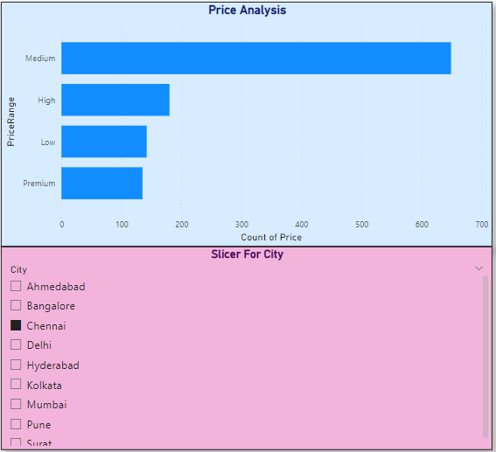

**TASK 8: Delivery Time Analysis**

**Analysis:** Examined the average delivery times of restaurants.

**Findings:** Delivery times vary significantly by area, with some congested regions having longer delivery times. Restaurants with faster delivery (under 30 minutes) tend to have better customer ratings.

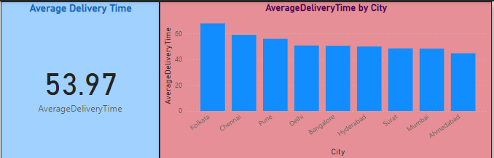

**TASK 9:** **Cuisine Analysis**

**Analysis**: Analyzed the variety of cuisines offered by restaurants.

**Findings**: Indian cuisine dominates the offerings, followed by fast food and Chinese. A growing trend of international cuisines such as Italian and Japanese is also observed in metro cities.

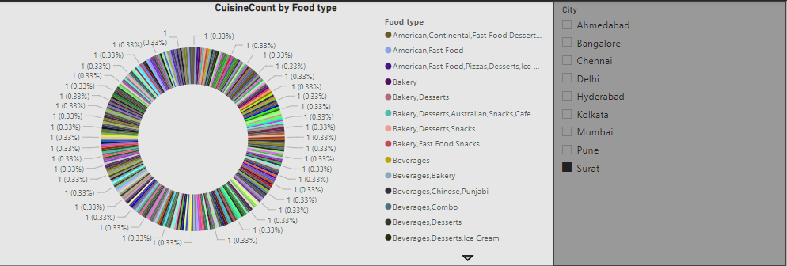

**TASK 10: Area-wise Restaurant Analysis**

**Analysis**: Counted the number of restaurants in each area within the city.

**Findings**: Certain areas, like tech parks or office hubs, have a significantly higher number of restaurants due to the concentration of office workers and lunchtime demand.

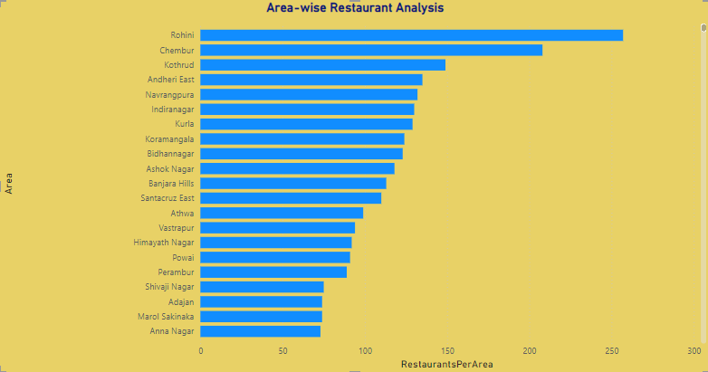

**Task 11:** **Correlation Analysis**

**Analysis**: Investigated correlations between variables such as price, ratings, and delivery time.

**Findings**: There is a slight positive correlation between delivery time and lower ratings, suggesting that delayed deliveries often result in poorer customer reviews.

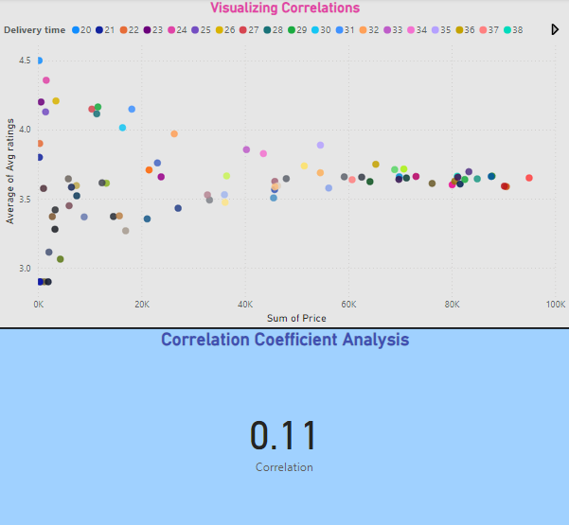

**TASK 12:** **Customer Feedback Analysis**

**Analysis**: Analyzed customer feedback based on ratings and total ratings.

**Findings**: Restaurants with higher total ratings (i.e., more feedback) generally have more consistent average ratings. Popular restaurants tend to maintain high customer satisfaction through service quality.

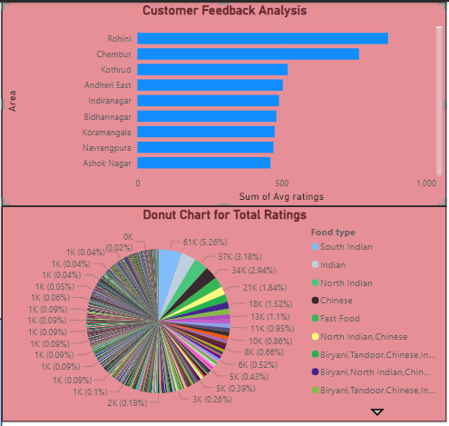

**TASK 13:** **Geographical Mapping**

**Analysis**: Mapped restaurant locations geographically.

**Findings**: High-density areas for Swiggy restaurants are typically near commercial centers and residential hubs. This provides insights into customer preferences and where future restaurant partnerships could be expanded.

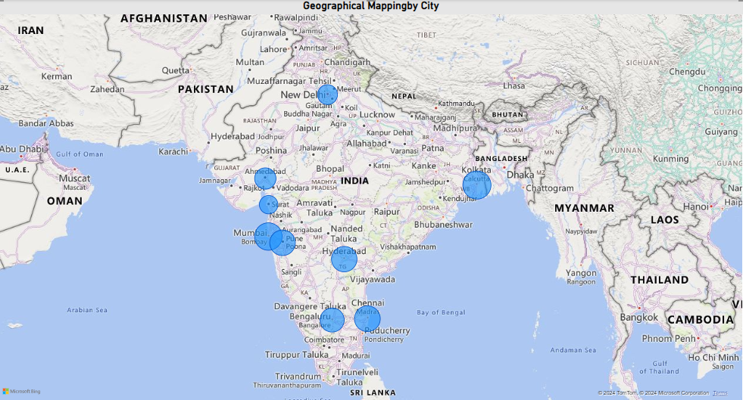

**TASK 14:  Business Recommendations**

**Analysis**: Based on all previous findings, actionable recommendations were derived.

**Findings**: Focus on improving delivery times, optimizing pricing, and promoting top-rated restaurants in key areas can help enhance customer satisfaction and drive growth for Swiggy.

* **Improve Customer Ratings**: Focus on improving service quality and delivery speed for restaurants with low ratings to increase customer satisfaction and drive repeat business.
* **Promote Top-Rated Restaurants**: Use top-rated restaurants (those with 4.5+ ratings) in promotional campaigns to attract more customers and boost platform credibility.
* **Expand Popular Cuisines**: Encourage restaurants to offer more of the popular cuisines identified in each city, increasing customer engagement and satisfaction.
* **Optimize Delivery Times**: Work on reducing delivery times, especially in areas where longer delivery times affect customer ratings, to improve overall customer experience.
* **Price Optimization**: Suggest restaurants offer competitive pricing based on customer preferences and ratings, balancing affordability and quality to attract a broader audience.